The Mixed Nuts
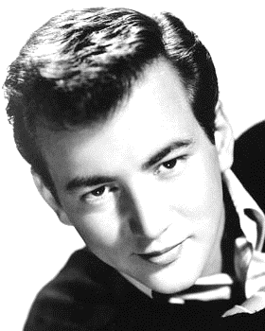
Set CC Last revised on 2016.02.28

CC01-Ain't She Sweet(KV).pdf
CC02-Cruising Down The River(KVF).pdf
CC02-Cruising Down The River(KVM).pdf
CC03-Bali Hai(KVF).2014.10.03.pdf
CC03-Bali Hai(KVM).pdf
CC04-Boo Hoo(KVF).pdf
CC04-Boo Hoo(KVM).pdf
CC05-Blues In The Night(KVF)2015.10.26.pdf
CC05-Blues In The Night(KVM)2015.10.26.pdf
CC06-Wooden Heart Polka(KV).2014.01.11.pdf
CC07-All By Myself(KVF).2016.02.28.pdf
CC07-All By Myself(KVM).2016.02.28.pdf
CC08-Bushel And A Peck, A(KVD).pdf
CC09-Splish, Splash(KVF).2015.05.10.pdf
CC09-Splish, Splash(KVM).2015.05.10.pdf
CC10-Dream Lover(KVF).2016.02.28.pdf
CC10-Dream Lover(KVM).2016.02.28.pdf
CC11-Mack The Knife(KV).2016.02.14.pdf
CC12-Bibbidi-Bobbidi-Boo(KVD).pdf
CC13-April In Paris(KVF).pdf

CC13-April In Paris(KVM).pdf
CC14-By The Light Of The Silvery Moon(KVD).pdf
CC15-Alice Blue Gown(KVF).pdf
CC15-Alice Blue Gown(KVM).pdf
CC16-Blue Tango(K).2014.06.20.pdf
CC17-Jump, Jive, And Wail(KV)2015.10.26.pdf

